А.В. Костарев, Т.А. Костарева
There are supports, whose reaction is limited by module. This includes the case of friction. In statics we are interested in the limit state of body rest when the reaction reaches its limit value and the body is about to start moving.
LIMIT STATE OF EQUILIBRIUM
External friction.
Coulomb Law.
We call external the friction between the surfaces of the investigated body and of the body of support. Friction is a complex physical phenomenon, which has both negative and positive properties. Friction is subject of the science called Tribology. In engineering calculations we usually operate with the models reflecting the physical phenomenon with some degree of accuracy.
Consider a body at rest on the horizontal rough plane (Fig.1). It is under the action of the force of gravity$P$ and normal reaction $N=-P$. To budge the body along the plane, we should apply some horizontal force $F$. This means that force $F$ causes resistance. Horizontal component $F_{тр} o$f the plane reaction $R$ is called force of friction.
As long as the body remains at rest, the conditions of equilibrium are true
F
P
N
$$F_{тр}$$
R
a
h
K
Fig.1
$$V_{x}: F+F_{трx}=0; F_{трx}=-F$$
$V_{y}: N-P=0; N=P \left(1\right)$
φ
$${ M}_{K}: Pa-Fh=0; a=\frac{F}{P}h$$
From the first equation (1) see that at rest the force of friction $F_{тр}$is equal by modulo and opposite by direction to the active force F.
Fig.2
$$F$$
$$R$$
$$P$$
φ
The last equation (1) shows that the force F causes the displacement of the point K of application of reaction R toward the force F. Thus, the body at rest is under the action of two force pairs: {F,F_{тр}} and {P,N}. They have equal by modulo and opposite by direction moments.
On the other hand, the body is in equilibrium under the action of three forces: F, R, P. It means that they all intersect at a single point (fig. 2).
Курс лекций А.Костарева
Increase of the driving force F increases the force of friction $F_{тр}$. At a certain value of the driving force F the body starts to slide over the surface. This means that at the limit state of equilibrium module of the friction force reaches the limit value $F_{тр}^{*}$.

Angle of friction.
Experience shows that, at first approximation, the limit module of the force of friction $F_{тр}^{*}$ depends on the module N of normal reaction under Coulomb law
$$F_{тр}^{*}=fN (2)$$
Constant f is called coefficient of friction.
Coefficient of friction f is a dimensionless value, depending on the materials and the surfaces in contact (roughness, temperature, humidity, etc.). Coefficient of friction f is determined by experience. In a pretty wide range it does not depend on the area of the contact surfaces. In the references, the following values of the coefficients of friction can be found: tree on tree 0.4 -0.7; metal on metal -0.25 0.15; steel on ice 0.027.

Thus, the module of force of friction may vary within
$$0<F_{тр}<F_{тр}^{*}=fN$$
Full reaction of support
$${R=N+F}_{тр}$$
is rejected from the normal to the surface at some angle φ. Figures 1 and 2 show that
$$tgφ=\frac{F_{тр}}{N}$$
At the moment when the body starts to slip $F_{тр}=F_{тр}^{*}$ and angle φ reaches its maximum value ∝ called angle of friction
$tg∝=\frac{F_{тр}^{*}}{N}=f (3)$
Tangent of friction angle ∝ is equal to the coefficient of friction f.
At the rest of the body angle $φ$ (Fig.2) may vary within
$$0≤φ≤ ∝$$
Курс лекций А.Костарева
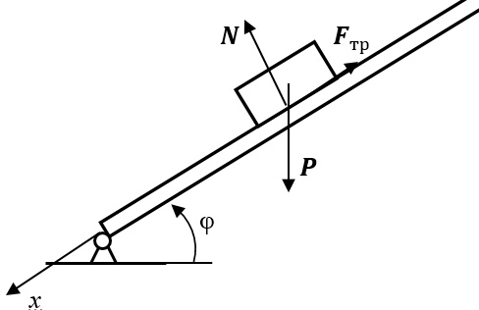
Consider a simple experiment, which allows practically measure the angle of friction. Put the body on a turntable. Will increase the angle of the tilt table to the value of $φ_{max}$, in which the body will start to slide down.
Fig.3
We will show that $φ_{max}$ is equal to the angle of friction $∝$. Projecting on the x axis all the forces that act on the body, we obtain
$$PSinφ_{max}-fPCosφ_{max}=0$$
From here
$$tgφ_{max}=f=tg∝; φ_{max}≡ ∝ (4)$$

Friction cone. Self-locking.
𝛼
φ
N
Q
$$F_{тр}$$

Fig. 4
Consider a weightless body on a horizontal rough plane with coefficient of friction f (Fig. 4). Construct a cone with a vertical axis and angle of friction ∝ at top two corners, and call it friction cone.
Show that no any force Q applied to the body inside the friction cone $φ<∝$ shifts the body. Shear force
$$F=QSinφ<QSin∝=Qtg∝Cos∝<QfCosφ=Nf=F_{тр}^{*}$$
or
$$F<F_{тр}^{*} (5)$$
for any value of force Q
Fig. 5
It means that, if the force is applied inside the friction cone, the body remains at rest. This property is called the phenomenon self-locking.
It is one of the many beneficial properties of friction. Without friction we would not be able to walk, the cars would not be able to move.
At the same time when we run up the icy hill, we intuitively try to shove from the ice at an angle that is less than the angle of friction.
All the screws (Fig. 5) have a thread angle less than the angle of friction of the screw on the nut, which prevents the unscrewing at vibration. The fine thread screws have the minimum angle of the thread, and the maximum self-locking.
Friction of rope on cylinder (Euler problem)
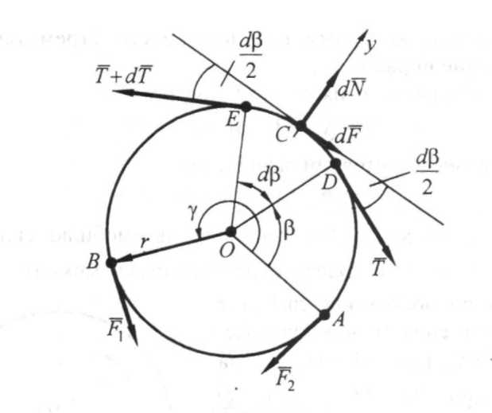
Let the cylinder be held by the rope, one end of which is tensioned by force $F_{1}$ (fig. 6). We define the force $F_{1}$ at the other end of the rope which can counterbalance the force $F_{2}$, if the angle of the rope contact is 𝛾, and coefficient of friction of the rope on the cylinder is f.

Fig.6
Consider the balance of elemental plot of rope DE of length $ds=rdβ$, where r is the radius of the cylinder. In points D and E the tension of the rope will be $T$ and $(T + dT)$. The rope plot also undergo the force of normal pressure of cylinder $dN$ and friction force $dF$ at the middle point C.
The sum of projections of all forces on the tangent to the cylinder is zero.
$$dT = dF$$
The smallest value of force $F_{2}$ will match the limit case of balance, i.e. the Coulomb's law
𝑑𝑇 = 𝑓𝑑𝑁.

Projecting all forces on the normal y, find
$$dN=\left(T+T+dT\right)sin\frac{dβ}{2}=2T\frac{dβ}{2}=Tdβ$$
Now :
$$dT = fdN=fTdβ$$
Separate the variables and integrate over the equation from F₂ to F₁ and from 0 to 𝛾:
$$\int_{F_{2}}^{F_{1}}{\frac{dT}{T}}=f\int_{0}^{γ}{dβ}$$
Hence
$$ln\frac{F_{1}}{F_{2}}=fγ$$
or
$$F_{2}=F_{1}e^{-fγ} (6)$$
When f = 0, $F_{2}=F_{1}, as expected$. Increasing the angle of 𝛾, we can significantly reduce the force $F_{2}$. For example, if f = 0.5 and γ = 4π: $F_{2}$ = 0, 002$F_{1}$.
The significant reduction in the tension of the rope, wrapped on a pillar, is used for mooring ships to berth.
Курс лекций А.Костарева

Keelover
Suppose you want to move a wardrobe of weight Р along the floor with coefficient of friction f, pushing it by horizontal force $F$ (Fig. 7). Experience tells us that if we push the wardrobe at its legs, it will begin to slide on the floor. If we push the wardrobe on the linoleum (high friction) at high point, then the wardrobe will not slide, but will begin to keel over. Find out when and why this happens.
Keel over
R
Fig.7
А
F
С
P
slip
H
a
𝛼
h
h*
С*
At the limit state of rest, before the start of keel over, the floor reaction $R$ deviates from the vertical by angle of friction $α=arctgf$. As is known, all three force P, F, R intersect at the same point C.
Picking up the point C of force application, we move the reaction R to the corner A, where it will come when
$$h^{*}=\frac{a}{2}ctg∝=\frac{a}{2f} (7)$$
С*
Thus, the mode of the wardrobe movement after the limit equilibrium state depends on the ratio of the height of the wardrobe H and the distance $h^{*}$::
- If the coefficient of friction f, and thus the friction angle 𝛼 are so small that
$${f<\frac{a}{2H}; (h}^{*}=\frac{a}{2f}>H)$$
the wardrobe will slip forward with at any h
- With big enough coefficient of friction $(f>\frac{a}{2H} и H>h^{*})$ there are two sections of the wardrobe:
If we apply the force F at $h<h^{*}$ the wardrobe will start transition.
The limit equilibrium state before the rollover is at $h=h^{*}$ when moments of forces F and P about the point A are equal:
$$Fh^{*}=P\frac{a}{2}; μ_{max}=\frac{F}{P}=\frac{a}{2h^{*}}=f$$
We find another practical way to determine the coefficient of friction f by measuring the distances a and $h^{*}$.
At rollover when $h>h^{*}$ the force F creates unbalanced torque $F(h-h^{*})$ about the point С*, and the wardrobe begins to rotate around the point A.
Thus, if $f>\frac{a}{2H}$ tilting the wardrobe is easier the higher it is (the smaller is the coefficient μ). Force F will be minimal, if it is applied at H. Then:
$$μ_{min}=\frac{F}{P}=\frac{a}{2H}; \frac{a}{2H}<μ< f$$
$$F$$
$$P$$
$$a$$
$$H$$
$$β$$

Fig.8
Wheel
Consider the change of coefficient μ with increasing the number n of sides of isosceles section of the body. Denote the length of the side by a (fig. 9). Assume that friction of the body on the surface is strong enough to let us roll the body by horizontal force F:
$$f>\frac{a}{2H}$$
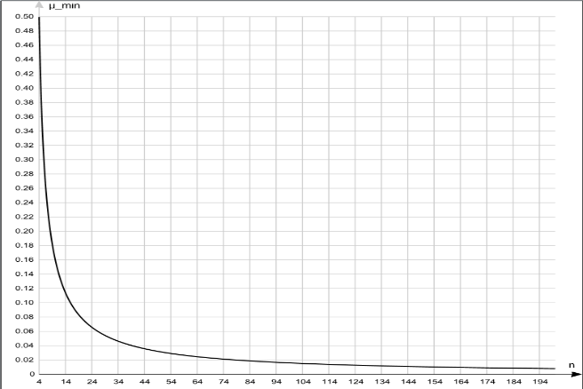
From Figure 8 we find
Fig.9
$$\frac{a}{H}=tg\left(\frac{β}{2}\right)=tg\frac{π}{n}$$
Hence
$$μ_{min}=\frac{1}{2}tg\frac{π}{n}$$

It is clear that if the n → ∞, i.e. making section in circle $μ_{min}$ and force F tend to zero. We come to the obvious conclusion that it is the easiest to roll the body with round section.

Dependence of $μ_{min}$ (n) is shown in Figure 10.

Internal friction

The real body is not absolutely solid. When a wheel is rolling on the road, both the wheel and the road are being deformed. This deformation is viscoelastic, that is accompanied by internal friction. The result is a resistance to movement of the wheel on the road. Its nature can be understood if we consider the limit state of wheel rest before it starts to drive under the action of torque (driving wheel) or the central force (driven wheel).

Курс лекций А.Костарева
Torque of spin resistance.
First, examine the resistance to rotation of a soft drive wheel on absolutely solid horizontal road caused by internal friction of the wheel’s material. This may be a flat drive wheel of the car on asphalt (Fig.10).
$$N$$
$$P$$
$$N$$
$$P$$
$$P$$
$$M$$
$$N$$
$$k$$
$$a$$
$$M^{*}$$
$$N$$
$$P$$
$$M^{*}$$
$$m_{тк}$$
Fig.10
Fig.11
Fig.12
Fig.13
Distributed normal reactions of the road on the wheel and their resultant N are always normal to the road.
At the absence of the driving torque M plot of normal reactions is symmetrical, and the resultant
N runs through the center of the wheel (Fig. 10).
If apply to the wheel a small torque M, then the resultant N remaining vertical, moves toward the torque action by some amount a (Fig. 11). Just as this happens at rollover.
If we increase torque M up to a certain value М*, corresponding to the limit state of the wheel rest before it start to rotate offset a reaches the maximum value k, which is called the coefficient of rolling friction (Fig. 12).
At this point force of gravity P and reaction N form a force pair with torque
$$m_{тк}=Nk$$
called moment of rolling friction.
So instead of the picture (Fig. 12) sometimes we draw an equivalent picture (Fig. 13).
It should be noted that the center of the wheel will start moving only when the force friction appears after the torque M exceeds the limit value of М*. Until that there is no force of friction.

Driven wheel
Picture of acting forces at the limit state of rest of the wheel is on the Figure 14. Contrary to the driving wheel the friction force $F_{тр}$ is always present and together with the limit driving force $F^{*}$ creates the turning couple ${\{F}^{*}F_{тр}\}$..
$$N$$
$$P$$
$$F^{*}$$
$$m_{тк}$$
Fig.14
$$F_{тр}$$
It should be noted that the wheel may not start to rotate, if the grip is not good enough. In this case, the friction force $F_{тр}$reaches the limit value $F_{тр}^{*}=fN$ before it does the rolling friction moment.
$fNr<Nk$ или $fr<k$
The wheel will start to move in transition, without rotating. So, a flat driven wheel will be skidding, moved by the driving wheels. Spin resistance has nothing to do with translation of the body, only with its rotation.
Курс лекций А.Костарева
Road resistance
$$P$$
Рис.158
$$R$$

$$R$$
$$P$$
$$P$$
$$F$$
$$R$$
$$k_{1}$$
$$a$$
$$F^{*}$$
$$N$$
$$P$$
$$F_{c}$$
Рис.16
Рис.17
Рис.18
$$F^{*}$$
Consider the resistance of internal friction in a soft road to translation of an absolutely solid wheel. First consider the driven wheel, since the central driving force F is always able to overcome any resistance to the road.
Distributed normal reactions of the road and their resultant R always pass by the center of the wheel.
In the absence of the driving force $F$ the plot of normal reactions is symmetrical, and the resultant $R=-P$ is vertical (Fig. 15).
If we apply a small central driving force $F$, then the wheel will stay at rest, and the point of application of reaction R moves to a certain value a in direction of F (Fig. 16).
If we increase the force $F$ to a certain limit $F^{*}$ corresponding to the limit stay of rest of the wheel before moving the gap a reaches its maximum value $k_{1}$ (Fig. 17), which is called coefficient of road resistance.
Meanwhile the vertical component N of reaction R balances the force of gravity of the wheel P. Horizontal component $F_{c}$of reaction R , called force of road resistance, has a module
$$F_{c}≅N\frac{k_{1}}{r} (8)$$
and balances the limit driving force $F^{*}$. So instead of picture (Fig. 17) we often draw the figure (Fig. 18).
It is remarkable that the resistance force is inversely proportional to the radius of the wheel. This is why the off-road vehicles have large wheels.
In addition, not knowing the formule (8), peoples of the North have always made a maximum radius of curvature of the strips at the leading end of the sleds. Because the resistance force (8) has nothing to do with rotation, it is associated only with its transition movement.
It should be noted that the driven wheel will start rotating only when the friction force $F_{тр}$appears after the driving force $F$ exceeds its limit $F^{*}$.

Driving wheel
In the limit state of rest before the center of the driving wheel starts to move the force picture will look like in Figure 19.
$$F_{тр}$$
$$M^{*}$$
$$F_{с}$$
$$N$$
$$P$$
Fig.19
Unlike in the driven wheel, the friction force $F_{тр}$ appears with any value of the driving torque M. At the rest forces $F_{с}$and $F_{тр}$make a pair of resistance ${\{F}_{с}F_{тр}\}$, balancing the driving torque M.
It should be noted that the center of the driving wheel can stay at rest if the grip with the road is not good enough. In this case, the friction force $F_{тр}$reaches the limit value of $F_{тр}^{*}=fN$ before it does the resistance force$F_{с}$. The wheel starts to slip without rotation. So may happen when we drive in deep snow.
Сcondition of lack of slippage
$$fN<N\frac{k_{1}}{r}$$
or
$$fr<k_{1}$$
Курс лекций А.Костарева
In general case, when both the wheel and the road are deformable we have both moment of rolling friction $m_{тк}$, and the force of road resistance of the road $F_{с}$. Picture of the applied forces at an extreme state of rest before moving is presented in Figure 20. The resultant equivalent is in Figure 21.
$$F_{тр}$$
$$M^{*}$$
$$F^{*}$$
$$R$$
$$P$$
Fig.20
$$F_{тр}$$
$$M^{*}$$
$$F_{с}$$
$$N$$
$$P$$
Fig.21
$$k$$
$$k_{1}$$
$$F^{*}$$
$$m_{тк}$$

